NEWS RELEASE
Contact:
Juleah Tolosky
Minnesota FFA Executive Director
Email: jtolosky@umn.edu
Phone: 518-832-0313
Richert Selected to Serve Minnesota FFA
Agricultural Education is fortunate to have many talented young leaders eager to take on leadership positions. Minnesota FFA is proud to announce Noah Richert of Springfield as the 2020-2021 FFA State Secretary.
"During my junior high years, I remember seeing people walking around the halls in their national blue corduroy jackets. I always thought it was so cool and wanted to be just like them; I could not wait for the day when I could finally be a part of what they stood for," shares Noah Richert, Minnesota FFA Secretary.
Noah's leadership and service to others are evident from his experiences in FFA, community service, National Guard, and work in agriculture.
COVID-19 presented unusual disruptions in the order meetings that were held for many agricultural groups. Within FFA, the selection of officers occurred nearly a month later than originally scheduled.
Due to an unforeseen conflict, an officer chose to resign. This allowed for the selection of Richert to complete the dynamic officer team.
"We are excited and proud to have Noah as part of this team. He brings a perspective and example that members can learn from, and we are excited for the contribution he will make," shares Juleah Tolosky, Executive Director of the Minnesota FFA.
Additional Media Resources
Reporter Anna Euerle of Litchfield is excited "to be able to take a unique opportunity to connect with students virtually! This allows for so many students to have opportunities they wouldn’t have previously been able to have."
President Ben Olander of Staples shares, "Never give up on your dreams no matter how big or small they are because you never know when that dream could become real." He is excited to "serve FFA by building connections and strengthening agriculture for the future."
Treasurer Elaina Knott of Thief River Falls is most excited "to make connections with FFA members this next coming year and see their growth and progress through this extraordinary organization." She advises, "Take ALL the opportunities that are offered through this organization. They are worth your time!"
Sentinel Laney Swiers of Bejou shares, "I am most excited to serve the incredible members and continuing advocating for agriculture, education, and FFA! My advice would be to always be your genuine, beautiful self. You are your most amazing self when you are sticking true to who you are!"
Vice President Emilee Xayanourom of Mountain Lake loves that "there is something for everyone in FFA!" She shares that members should talk to your advisor because "they’re in there to help you. They are in that role for a reason so don’t be afraid to ask for help or some advice!"

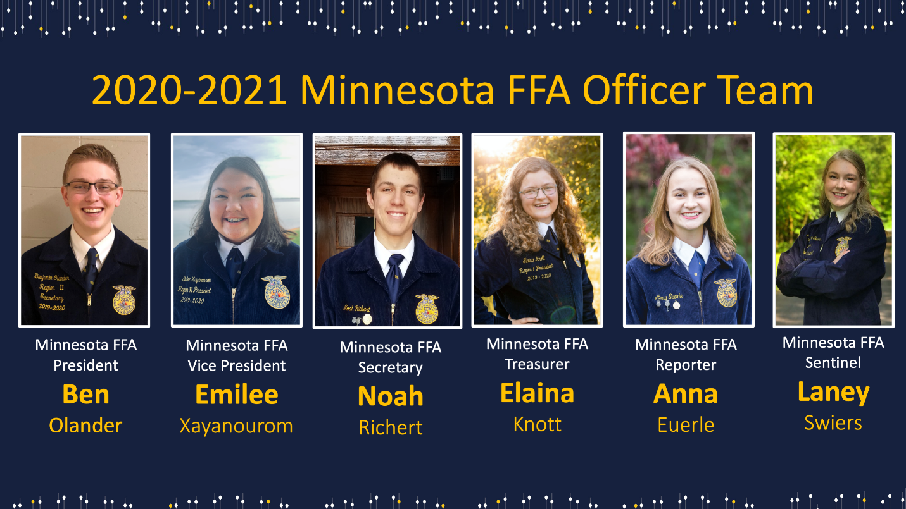
###

About Minnesota FFA
FFA is a national organization developing students’ potential for premier leadership, personal growth and career success through agricultural education with more than 7000,000 members in all 50 states, Puerto Rico and the U.S. Virgin Islands. The Minnesota FFA Association represents nearly 11,000 members and nearly 200 high school chapters across the state. Agricultural education engages students through hands-on learning in the classroom, work-based learning opportunities known as Supervised Agricultural Experience (SAE) projects and FFA activities. You can learn more about the experiences of FFA members and supporters by visiting www.mnffa.org and www.ffa.org.

